SYLLABUS FOR
SHOW CHOIRS /VOCAL ENSEMBLES

DRAFT ONLY
Sample photos to be replaced by local choirs/ensembles

SYLLABUS FOR
SHOW CHOIRS /VOCAL ENSEMBLES

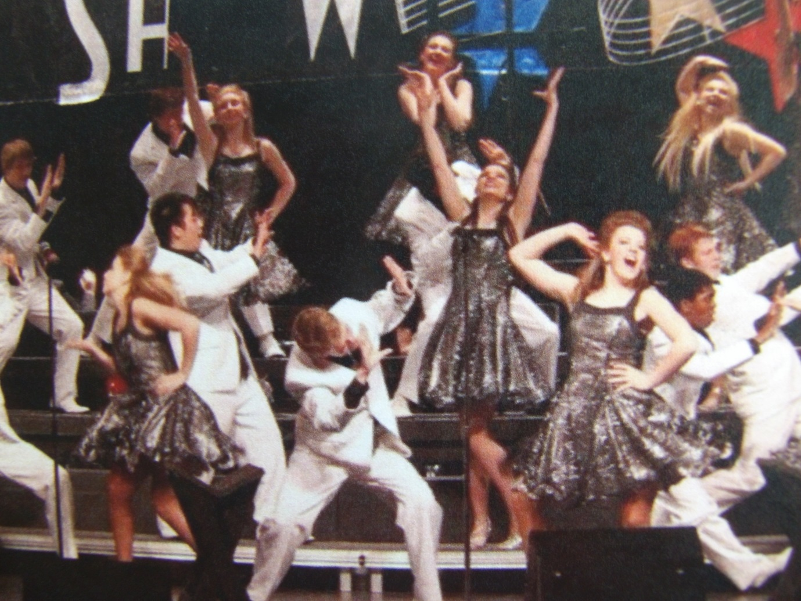

SYLLABUS
INTRODUCTION
These syllabi are designed to meet the needs of those teaching and learning music, speech, drama and theatre arts. The examinations will be found to be comprehensive and catering for those interested academically or as a performer. The lists contain works ranging from early times to up-to-date contemporary examples, plus own choice options.

All work is carefully and sequentially graded. Teachers preparing students for these examinations will have a very sound outline on which to develop their lessons. These examinations make provision for many abilities and give a goal for students in their studies. They provide a sense of purpose and direction and can be taken in addition to other activities, as they are not intended to be the only studies in a student’s year. Examination reports reflect a reliable assessment of progress and, by comments and marks, assist individual development.

In each syllabus, teachers will find the requisites of a system of training for their students through the Grades to the Diploma levels. The aim is to encourage personal development in music, speech, drama, theatre arts and performance in each individual. It is the intention to help teachers and their students in the development of their skills, acquisition of knowledge and enhanced self-confidence according to age and experience, not to discourage and set impossible or unrealistic standards.

At each examination level, selections are made from each section list of specified works or own choice. Own Choices give an opportunity for teachers and candidates to explore the repertoire appropriate for individual grade level, age, interest and experience and thereby have some ownership of their examination program. It is expected that all Own Choice items will be thoughtfully and responsibly selected and provide challenge and motivation for individuals in order to assist personal development. Examiners will expect standards of achievement commensurate to the candidate’s age and grade level, and to show thorough preparation for each examination component and section.

An exciting section is the ‘Performance Examinations’. Many students wish to learn music, speech, drama and theatre arts as a leisure activity and would like to receive recognition of their progress – these examinations are the answer as the assessment is based on the candidate’s performance, not the technical or theoretical aspects. Students may present a wide variety of items in the Performance Examination as the syllabus allows for the teacher and candidate to choose the performance pieces. Candidates in this area may progress to the Diploma of Performance.

Syllabi have been specifically designed for Show Choirs and Vocal Ensembles, and Drama Production.

These syllabi have been designed in response to many requests from teachers of music, speech, drama and theatre arts looking for an alternative examination system. These examinations are perceived to be more flexible and user-friendly than some other examination systems. All examiners are highly qualified and experienced teachers and therefore have a good understanding of the problems faced by both teachers and students.

OVERVIEW
This syllabus will provide participating choir candidates with a range of performance skills with respect to ensemble awareness, by working through this graded structure of levels designed to encourage a resulting performance of choral items. Choristers are expected to contribute their time, talent, ability, effort, desire, determination, energy, passion, enthusiasm, self-discipline, commitment and a positive attitude to the teamwork involved.
The results of these individual contributions should :
- Expand and increase music knowledge, vocal technique, tone production
- Advance facility in reading music, sightsinging, theory and movement
- Increase knowledge in the realm of popular music literature, its background, interpretation, preparation and performance
- Develop and present an exciting performance
- Help develop maturity, responsibility and teamwork skills
- Foster lifelong appreciation of Choral music, friendship and social skills.
DEFINITION : A Show Choir consists of a group of choristers with an enthusiasm for combining choral singing with dance and theatre format presentation, either with or without a connecting thematic framework.

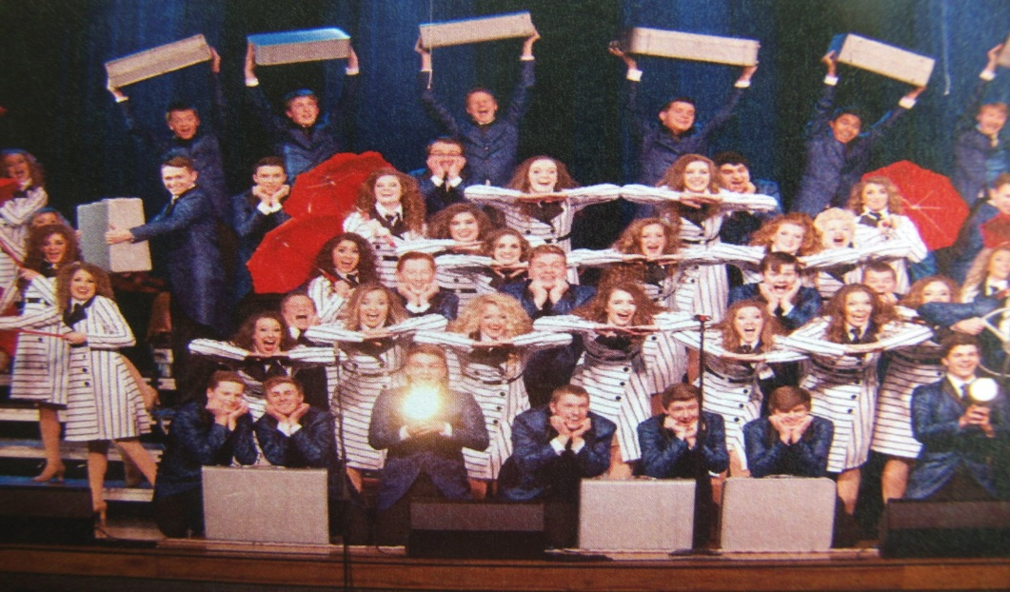
RATIONALE: The attainment of grade or diploma qualifications in a specific area of the performing arts, Show Choir, (which combines music, drama, creative movement and dance), enriches and equips each choir member with life-long understanding of teamwork and healthy competition through commitment and participation in a resulting ‘arts’ performance.
AIMS: This syllabus of sequentially graded levels, culminating in a diploma, is designed to promote education and personal development in the performing arts through music, drama, creative movement and dance.
OBJECTIVES: Participants who progress through this syllabus should develop a range of performance skills, ensemble and spatial awareness, acquisition of ‘arts’ knowledge, creative interpretation of specific repertoire for each level, critical thinking, communication techniques and evaluation.
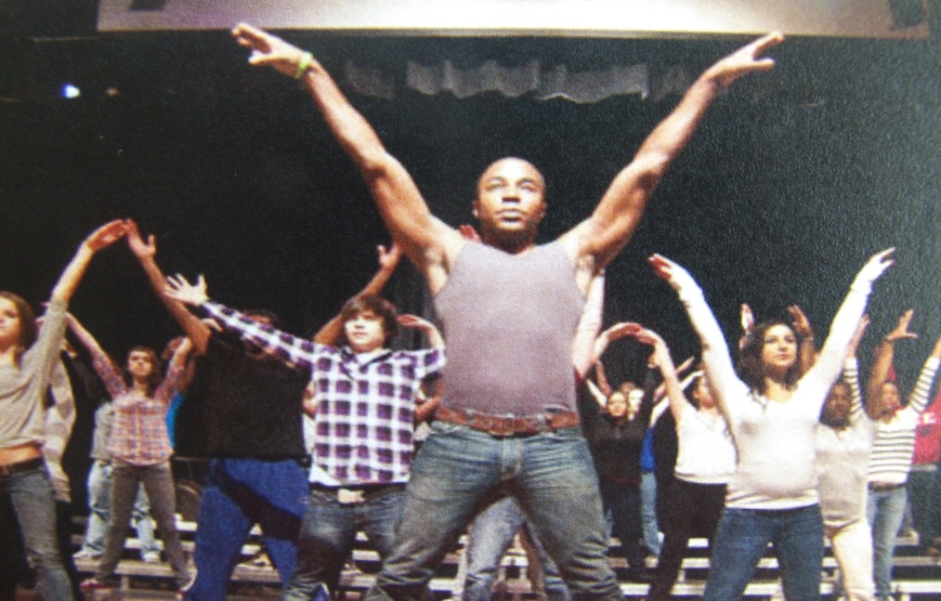
SUMMARY : This Syllabus is designed to prepare Show Choirs and Vocal Ensembles to present suitable repertoire (performance, presentation and written program)for assessment through specifically graded examinations from Initial Level to Platinum Level and the award of Diploma: Dip (Show Choir) These grades equate approximately from Grade 3 through to Diploma level in most Music, Drama and Performing Arts qualifications and awards offered by other Examination Boards.

REPERTOIRE : Genres for selection, which may be adapted, would include:
Music Theatre – Jazz - Barbershop/Adelines – A Capella – Madrigal – Cabaret – Gospel – Contemporary - Modern – Country/Western – Ballad – National – Folk Pop - Rhythm and Blues – Traditional – Sacred – Light Opera - Evergreens

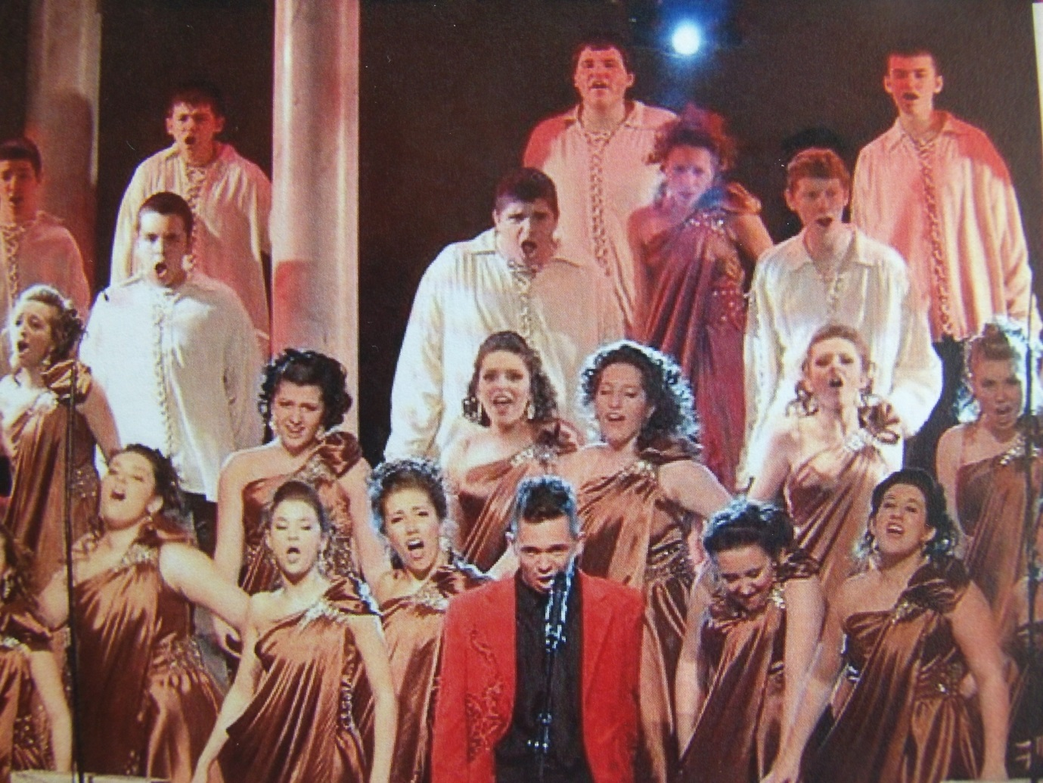

SELECTION: Music selected may be Stand-alone performance pieces or Thematically connected to present a concept or storyline. Care should be taken to compile a variety of balanced and contrasting songs. Choirs have totally free choice providing that the content of each piece is musically and technically appropriate to the performance level attempted.

REQUIREMENTS:
One song must be presented a capella with minimal or no movement One song must contain no physical movement or gesture One song must be presented at a slow tempo One song must be presented at a fast tempo
One song must have ‘novelty’ value aimed at producing audience laughter
At least one song must be sung in polyphonic harmony
At least one song must be : Staged At least one song must be : Choreographed
NB These above requirements may be combined where appropriate eg: fast, novelty and choreographed requirements might be included in one song. This would depend upon the number of songs presented.
All presentations must be memorised with own choice accompaniment
Costumes, accessories, scenery, properties are optional
Performance items should be presented in brackets or sets strictly within the time limits start-finish, including costume, scenery and staging set-up/down.
Brackets/sets should contain one or more songs and all brackets/sets should total the entire performance time.
Soloists may be included but are not assessed separately
Choirs must supply a suitable venue

GROUPINGS Choirs might typically comprise: Treble, Male, Mixed, Chamber There must be at least 12 choristers in each choir.

ASSESSMENT Performance 80% Presentation 10% Written Program 10%
ASSESSMENT CRITERIA :
The assessment of the sequentially graded exams will reflect achievement in developing musicality, challenges and levels of mastery appropriate to levels to include, but not restricted to the following examples: Level 1: basic melodic, rhythmic and dynamic control, articulation, expression Level 2: as above, but more demanding including phrasing, ornamentation Level 3: more complex melodic, rhythmic and music demands Level 4: as above, plus modulations, developing vocal dexterity and musicality Level 5: as above, plus vocal personality and significant degrees of complexity Level 6: advanced quality standard of all musical and performance components
Overall Performance assessment, appropriate to the levels, will include: vocal and physical ensemble cohesion, ability to communicate to an audience, musicality, understanding of the song genre, technical accuracy, phrasing, breath control, tempo, expression and dynamic range, tonal variation, vocal and physical flexibility, facial involvement, intonation, articulation.
Overall Presentation assessment, appropriate to the levels, will include: stage/platform etiquette, posture, spatial awareness, co-ordinated gestural and physical participation, importance of each individual contribution.
Overall Written Program assessment, appropriate to the levels, will include: written or printed style of compilation, design elements, appearance, formatting, clarity of intent, and interest to the reader.
The Written or Printed Program style should include the following : 1) Title page stating Show Choir Examination Level 2) Contents page outlining the Performance items 3) Relevant researched information on each piece and composer, and facts or anecdotes referring to the songs with supporting illustrations/images 4) Biographical notes relating to the Show Choir 5) References and bibliographic notes as appropriate.
Higher levels should include evidence of study/analysis of the music content.
Length of written content will be expected to vary with the levels but as a rough guide, Initial Level : 250 words, with increments up to 1500 for Diploma.
LEVELS Choir Level Performance Duration Brackets/Sets Award
1 INITIAL 15 minutes 3 Certificate 2 INTERMEDIATE 20 minutes 4 Certificate 3 BRONZE 25 minutes 4 Certificate 4 SILVER 30 minutes 5 Certificate 5 GOLD 35 minutes 5 Certificate 6 PLATINUM 40 minutes 6 Diploma
Candidates/Choirs must have successfully attained Level 3 (BRONZE) as a minimum requirement in order to enter higher Levels.

CERTIFICATES /DIPLOMAS
CERTIFICATE: Each candidate will receive a personalised individual Certificate of attainment and Level, including the name of the Musical Director and the Show Choir/Vocal Ensemble.
DIPLOMA : Nominals for Diploma level attainment are Dip(ShowChoir).

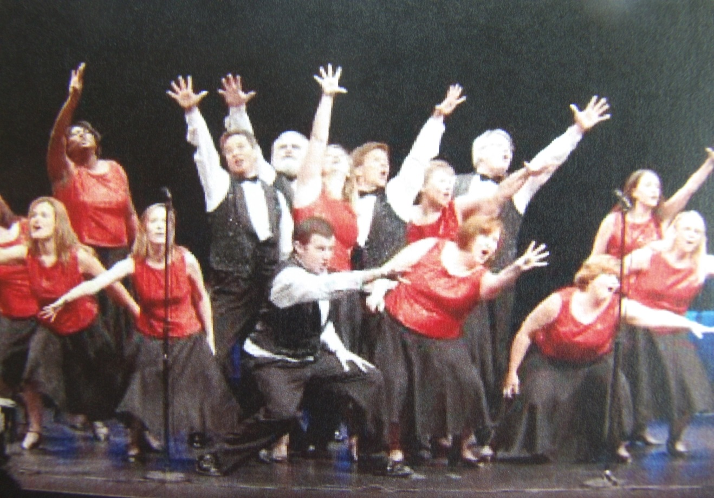

Intellectual property of T. Smith and D. Hines
imebshowcasechoirvocalensemblesyllabus2019

