‘ALL THE WORLD’S A STAGE’

WORLD THEATRE AND DRAMA SYLLABUS

WORLD THEATRE AND DRAMA SYLLABUS
‘ALL THE WORLD’S A STAGE’

Dr Darrell Hines (Secretary) PhD,MA,MEd,FIMEB,FTCL,LMusA,LTCL(CMT),LTCL(S&D),LSDA
Dr Tim Smith (Course Consultant) PhD,MEd,BEd,DipTch,ETC(Adv),FIMEB, FCSME, PGDES,LAGS,DipMus(Hon)
Merryl Lloyd AAGS, LAGS
Clare Wheatley AIMEB(P), PDip(IMEB), ExCert(IMEB)
Dr William Clark DMus(Hon), D.Litt, STD, MMus, MA, FIMEB, FRSCM, HonFGCM, HonFGMS,
HonFCSME, FVCM(Hns)

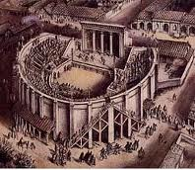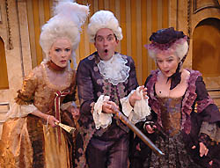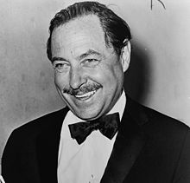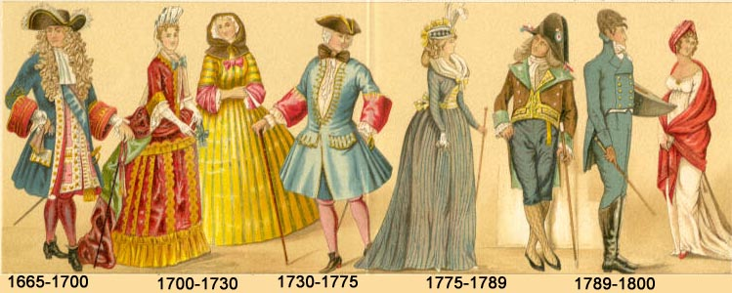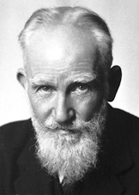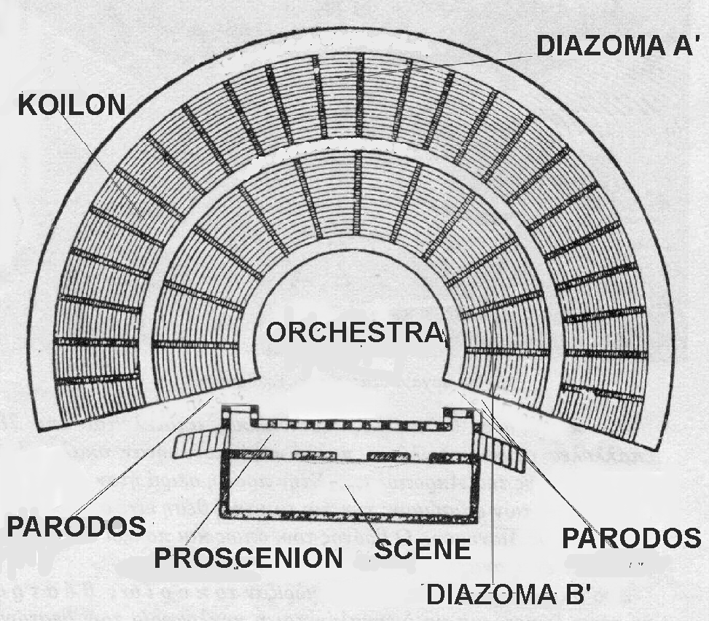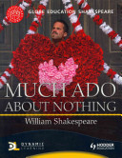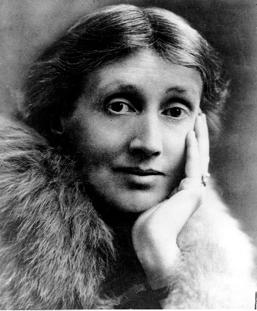
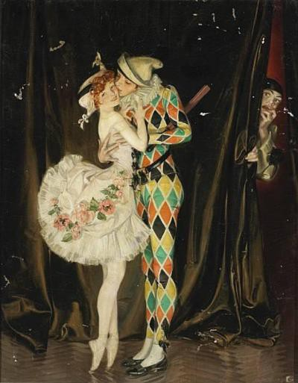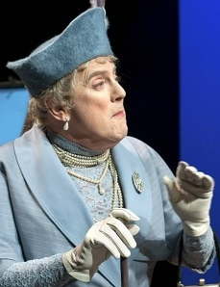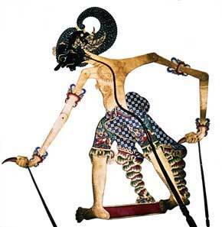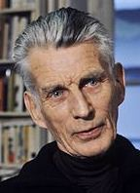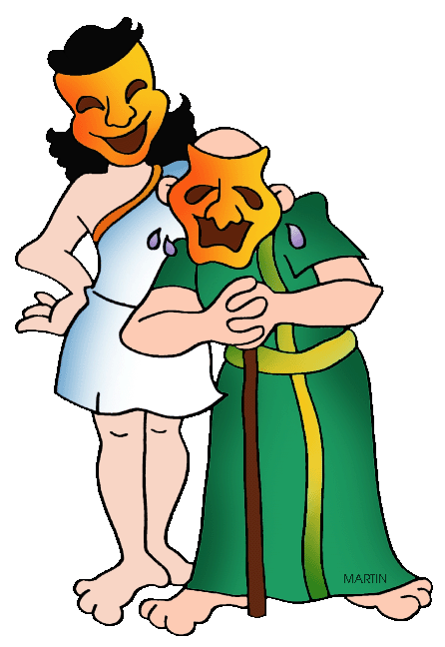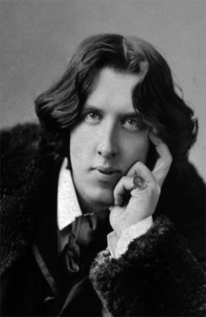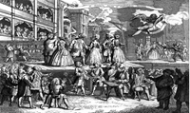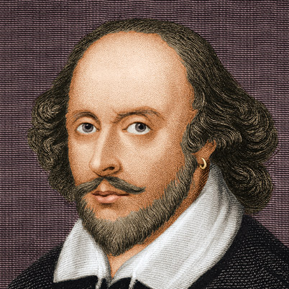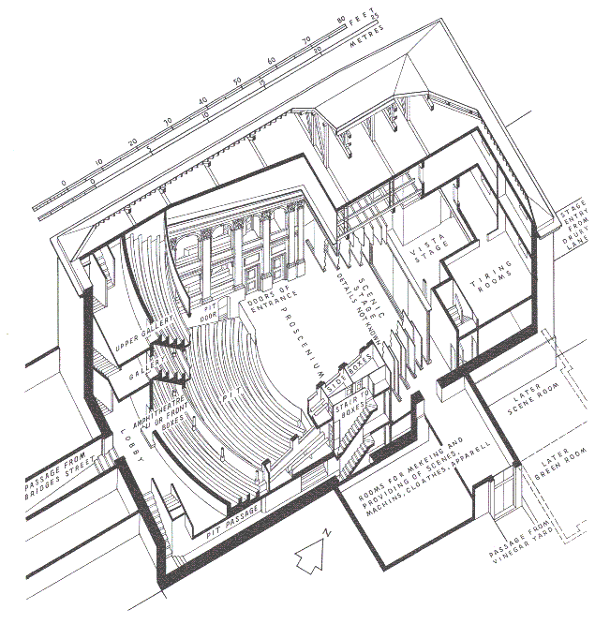

INTRODUCTION
This syllabus is designed for students who have an interest in studying, exploring and experiencing drama in its broadest context, both as a performer and from the academic aspect. The content of the syllabus cannot possibly be inclusive given that every country and culture in the world has its own history and breadth of drama development sufficient to warrant its own course of study. Instead, it is the intention of this syllabus to focus mainly on Western Drama but, where appropriate, reference is made to relevant or associated cultures.
As with live Theatre, Television and Film productions, most of the content of works presented on a stage or performance space are better suited to the more mature mind, hence the Parental Guidance classifications appended to such dramatic presentations. It is not compulsory to enforce this restriction on this syllabus; however, teachers would probably agree that Grade 1 would not be suitable for candidates under the age of 12 years. Consequently, at the rate of progressing through one Grade per year, it is envisaged that the higher levels would be more suitable for upper-teenage or older.
Syllabus content is sequential in depth and expectations whilst building on skills and knowledge acquired. It is designed to foster and enhance individual development, artistic expression, communication skills and confidence. Work and study topics will include such varied modes as playwrights, literature, characters, individual performances, staging, costume, lighting, publicity, media, production techniques, styles, talks and researching historical aspects of Western drama. Examiners will expect levels of achievement commensurate to the individual candidate’s age and Grade level and to show thorough preparation and rehearsal of each component of this Drama examination. Specified time durations should be adhered to reasonably closely, but not exceeded.
NB. All work should be thoroughly memorised except for sight-reading items or where otherwise stated. Palmcards may be used for talks but may contain only headline notes, dates, names, foreign words, quotations etc and are to be submitted to the Examiner. Palmcards which contain the text of the talk will incur a zero mark for that component of the examination. Use of non-assessable props, costumes, sound or other accessories to help presentation of any components are optional unless otherwise stated. Components/questions in each Grade exam are couched in general terms, thus enabling individual interpretation of the main gist without risk of feeling restricted. The underlying truth, integrity and focus of the question/task should at all times be retained.
There is an Own Choice at each Grade.
Explanatory notes and examples which follow each question are offered as a guide only.
The content is designed to be sufficiently in-depth in research, theoretical and performance requirements so that a corresponding Theory Syllabus is not thus not offered. However a Pass at Grade 8 is a pre-requisite for the Associate Diploma in World Theatre and Drama. Commonsense and professionalism are expected in interpreting this syllabus.

Examination Information

Grade 1 20 minutes
2 25 minutes
3 25 minutes
4 30 minutes
5 30 minutes
6 35 minutes
7 35 minutes
8 40 minutes
Associate Diploma 45 minutes

Specified durations of exams (above) slightly exceed the accumulated timings of each component within an exam to allow for smooth transition and access to props, costume accessories etc

GRADE 1 20 minutes
1 Prepared spoken, illustrated review of any stage production attended (3 minutes) This should be a memorised, concise, personal comment about any professional or amateur stage production of a play, musical, cabaret, comedy show or spectacular which the candidate has personally attended. Focal points would include overall impression of acting quality and production, effectiveness of communication and show’s message or plot, playwright, atmosphere, physical theatre environment and foyer, audience, and programs. Illustrations required. Palmcards containing only headline notes/names/dates etc to be submitted to the examiner. 20 marks

2 Simple Puppetry: present a prepared short conversation between two characters represented by any style finger puppets. This may be a published or devised script showing a situation development and climax. Voices should change for each character. (3 minutes) There are many styles of finger-puppetry. Simple faces drawn on fingertips would suffice with maybe a simple item for hat or hair to help denote the character. Eg: a tiny piece of white net for a ‘bride’ and a black curly moustache drawn with texta for a ‘villain’. No expensive or sophisticated props required. 20 marks

3 A prepared talk on the essentials of basic effective Vocal Technique (3 minutes) This would include demonstrating an understanding about breathing, clear articulation, pitch, pace, dynamic expression. Palmcards to be submitted to examiner cf No 1. 20 marks

4 Presentation of any solo ‘spoken’ characterisation from a musical (3-4 minutes) Eg: Female: Annie from ‘Annie’ (the musical) Male: Artful Dodger from ‘Oliver’ (the musical)
Simple costume/sound accessories may be used if organised in readiness on a table nearby for immediate and speedy access/operation without delay following the previous talk No 3. It is not necessary to sing, but meaningful locomotion, changing facial expression and physical gestures are expected to support the selected characterisation. This is basically a monologue, and text may be changed minimally to incorporate the presence of other characters in the scene if necessary. Appropriate accents are required. 20 marks
5 Own choice character presentation suitable for age from any published play (3 mins) Presentation of any ‘young’ published character from any country/period. Appropriate accents/dialect expected. Eg: Anne from ‘Anne Frank’s Diaries’, or David from ‘David Copperfield’ by Charles Dickens 20 marks
Total : 100 marks

GRADE 2 25 minutes
1 Prepared reading of a published drama review of any current play in production (2 mins) This review may be from any newspaper or magazine. Clearly spoken delivery should show appropriate expression and ability to read aloud and effectively to an audience. 10 marks
2 Presentation of a spoken solo ‘dramatic’ American or English characterisation (3 minutes) Eg: Eliza from ‘Pygmalion’ or Fagin from ‘Oliver’. Choice of character should be suitable to age of candidate. Appropriate dialects and accents are required. Published text may be altered in this monologue if necessary to establish the presence of other character/s. Quick and easily accessible minimal props and accessories are permitted. 15 marks
3 An illustrated talk on the history of ‘Punch and Judy’ puppet shows (3 minutes) This talk should cover the historical origins of ‘Punch and Judy’ shows in Italy, England and France, the main characters, the importance of audience participation, the Professor and the Bottler, and a sample storyline. Suitable illustrations should support the content of the talk. Palmcards may be correctly used. 15 marks
4 Impromptu personification of an inanimate object in a specific situation (2 minutes) The art of personification of an inanimate object is to assign it with human qualities for dramatic, artistic or literary effect. Use of imagination and forward thinking is required in this task. Examiner will present the candidate with two small objects (eg: a biro and an apple) and suggest a situation where these two objects might meet, eg on the kerb-side attempting to cross a busy road. A brief scene should be enacted on the floor or desk-top. Names should be introduced at the beginning eg “Good morning I’m Bluey Biro,” and “Hello Bluey, I’m Granny Smith.” The scene should have a definite conclusion. Personification is a powerful tool used by many dramatists. One minute preparation time. 10 marks
5 A short prepared talk (2 minutes) about any famous comedy character in drama followed by a (2 minute) demonstration of a famous scene or monologue associated with this character. There are many comedic characters and associated punchlines throughout the history of drama including contemporary comic characters in film and television. Candidates should select a suitable character to discuss before presenting a well-known tract of text associated with the character. Eg the ‘Handbag scene’ featuring Lady Bracknell in ‘The Importance of being Ernest’ by Oscar Wilde. Other characters immediately associated with comedy might include Blackadder, Homer Simpson, Hyacinth Bucket, Falstaff, Lady Sneerwell, Basil Fawlty, Dame Edna Everage Palmcards should not be necessary for this short talk 20 marks
6 Prepared reading of a dramatic extract from an American play or novel to include both narrative and dialogue suitable for the candidate’s age (3 minutes) American dialect is required for the dialogue passages as a contrast to the delivery of the narrative passages. Eg: For younger candidates: ‘Anne of Green Gables’ by L. M. Montgomery, or ‘Huckleberry Finn’ by Mark Twain, and for older candidates: ‘Barefoot in the Park’ by Neil Simon, or ‘The Glass Menagerie’ by Tennessee Williams 15 marks
7 Own choice character presentation suitable for age from any published play (3 mins) Presentation of any published character suitable for age from any country/period. Accents/dialect expected. 15 marks
Total : 100 marks

GRADE 3 25 minutes
1 Prepared reading of any humorous dialogue between two characters from any play published since 1800 (3 minutes) Contrasting characters should expose the drama and humour of the scene in the style of the period. Locomotion and some gesture is expected while holding the reading material. Props and accessories are not required. 10 marks
2 Prepared and memorised solo presentation of a ‘junior’ Shakespeare character (3 mins) Eg: Ariel, Puck, Bottom, Touchstone, Juliet. Locomotion, gesture, facial and vocal expression will be assessed in addition to convincing characterisation rather than simply delivering a recitation of memorised lines. The presence of other characters may if necessary be indicated during the solo dialogue and pauses between phrases/lines 20 marks
3 Prepared spoken description of a famous character in any field of drama with illustration or supporting chart (3 minutes) Candidate should select a famous dramatic character whose name automatically conjures up a particular image, costume, scenario and/or related dialogue/phrase. Eg: Dorothy from ‘Wizard of Oz’, Oliver Twist from ‘Oliver’, Jack Sparrow from ‘Pirates of the Caribbean’, Brutus from ‘Julius Caesar’, Jo from ‘Little Women’, Eponine from ‘Les Miserables’, Red Witch from ‘Alice in Wonderland’ etc. Candidate should describe the images, and focus on which aspects make the character instantly recognisable and famous. Clear speech is an expectation. 15 marks
4 Own choice character presentation suitable for age from any published play (3 mins) Presentation of any suitable published character suitable for age from any country/period. Accents/dialect expected. 15 marks
5 Prepared, illustrated talk on Medieval European Miracle and Mystery Plays (3 minutes) These dramas enacted throughout England, Italy, Germany and Spain developed from liturgical drama and religious ceremonies and became the forerunners of mainstream professional European drama in the 16th century. Candidates should comment on Miracle and Mystery plays, Guilds, Cycles, name some of the plays and describe the staging and special effects which delighted and terrified some audiences. Examiner may enter the discussion. 15 marks
6 Read an impromptu character monologue selected by examiner (2 minutes) A monologue suitable to the candidate’s age and gender will be selected by the examiner. A brief character analysis and the situation will be outlined to the candidate to assist the reading and character conviction. Dialects and accents may be required. (2 minutes preparation time) 10 marks
7 Present two comic anecdotes and one tragic story (3 minutes) Actors are expected to engage with audiences on a variety of levels, eg ‘Open Mike’ performances. This task requires different skills, vocally, facially and physically to effectively relate short stories and produce appropriate mood. Microphone is not required but a mock microphone may be held in a hand to show correct mike technique. 15 marks

Total : 100 marks

GRADE 4 30 minutes
1 Present an illustrated talk on any famous Australian stage or film actor (3 minutes) Examples of seminal roles and productions should be included plus brief quotes from critical reviews. 10 marks
2 Present an extract from any play by Noel Coward, Harold Pinter or Alan Ayckbourn. One character only. The distinctive style of each playwright should be expressed (4-5 minutes) Minimal props and/or accessories are permitted. Published text may be adapted slightly as necessary to help establish the existence of other characters. English accent is required appropriate to character selected. 15 marks
3 Demonstration of Comedia dell’arte. Own style presentation (4-5 minutes) An explanatory talk with physical and illustrated examples to demonstrate this significant Western drama development originating in Italy. Examples should include: Stock characters (Harlequin, Pantalone, Dottore, Pulchinella, Zanni), formation of the first professional acting companies, Lazzi, masks, importance of improvisation, farce, song and dance, origin of ‘slapstick’, travelling stages, sponsorship, and influences on later playwrights. 20 marks
4 Memorised own choice Australian lyric poem (approximately 200 words) (3 minutes) Monologues and soliloquies in drama are often poetic in form and require varied skills for correct interpretation. This includes phrasing, enjambment opportunities, introspection, vocal delivery clarity and overall quality. 10 marks
5 Historical overview of early Australian theatre/drama development pre-1950 (4-5 mins) The period 1780-1950 saw much development in theatre/drama/entertainment from overseas companies touring the new penal colony with minstrel shows, pantomimes, sketches and operas in various buildings from tents in the goldfields to newly constructed theatres in the growing capital cities. Over this period there was a developing sense of nationalism and Australian identity. Names and works associated with this period would include:Lola Montez, Roy Rene, Gladys Moncrieff, Steele Rudd, ‘The Squatter’s Daughter’, ‘The Sentimental Bloke’ and the New Theatre Movements of the 1930s whose productions reflected pre-WW2 class struggles in Australia and the Western World. 20 marks
6 A short talk on the duties of Stage Manager and Assistant Stage Manager (3 minutes) Both of these ‘backstage’ positions of Stage Management are essential to any theatre production. Responsibilities include overall supervision for all physical aspects of a production during the performance, ensuring smooth production, acting as adjunct to the Director, checking all cues are followed, liaising with technical crew, cast and management, the importance of “Standby” and “Go” or “Action” and keeping the ‘Prompt Book’ (the stage ‘bible’) updated. 10 marks
7 Own choice character presentation suitable for age from any published play (3 minutes) Presentation of any suitable published character from any country/period. Accents/dialect expected. 15 marks

Total : 100 marks

GRADE 5 30 minutes
1 Explain the difference between Irony, Satire, Sarcasm, and Parody (4 minutes) These genres/verbal devices are often employed by playwrights to heighten drama or entertainment value. Candidates should include an example of each (quoting any character, play and playwright) to support the explanation. 10 marks
2 Historical overview of Comedy of Manners. Own style presentation (5 minutes) 17th century Spanish Classical Drama and French Comedy of Manners influenced the development of English Restoration drama. Seminal figures include Lope de Vega, Moliere, Racine, King Charles II, Dryden, Jonson, Wycherley and Congreve. An illustrated talk should include 2 brief examples of memorised excerpts, with characters and plays suitably introduced. Palmcards should not be used. Minimal props and accessories may be used. 15 marks
3 Short talk on the differing roles of Director and Producer in a theatre company (4 mins) The differences would include controlling the artistic and dramatic aspects, fulfilling playwright’s vision, creating conditions for the production to materialise, obtaining rights, engaging a production team and cast, fundraising, initiating and co-ordinating entire production process from ‘Concept Meeting’ to ‘Opening Night.’ 15 marks
4 Presentation of an excerpt from Restoration Drama with props (4 minutes) Solo characterisation. Textual adaptations may be necessary to indicate the presence of other characters in the excerpt. Eg: ‘She Would if She Could’ by Etherege, ‘The Country Wife’ by Wycherley, and ‘The Way of the World’ by Congreve, each contain scenes from which ideal extracts could be taken for this presentation. The genre ‘Comedy of Manners’ in this Restoration Drama/period should be understood in order for full, accurate characterisation and maximisation of text content. 20 marks
5 Spoken interpretation of a descriptive ‘musical’ character’s song. Own Choice (4 minutes) Many characters are associated with songs/music eg Ado Annie and ‘I’m just a girl who cain’t say ‘No’‘ from Oklahoma in which she describes her own character. Candidates should select one own choice character from any ‘theatrical show’ plus associated song and give a spoken interpretation of the lyrics. The words should thus be regarded as text and delivered in a way as to receive new life or character interpretation through varied speech techniques, eg pauses, emphasis, phrasing, speed and dynamic variation, so that it no longer sounds like the familiar rhythmic and melodious song. Suggested characters might include: Scarecrow and song ‘If I only had a brain’ from ‘Wizard of Oz’; or Peter Mills’ ‘Way ahead of my time’ from ‘Taxi Cabaret’; or Jane and her song ‘I sit in the sun’ from ‘Salad Days’; or even Mimi’s introspective operatic aria ‘They call me Mimi’ from Puccini’s opera ‘La Boheme’ is ideal for re-interpretation of character. As a result of reinterpreting the lyrics as text, the characters might even change age, gender and nationality. 15 marks
6 Illustrated talk on the physical aspects that constitute an acting space/theatre (3 mins) An explanation of such aspects and terms as: stage, proscenium arch, flats, flyspace, cyclorama, act curtain, wings, traps, fourth wall, prompt box/corner, scrims, drops, thrust stage, black box stage and battens. 10 marks
7 Own choice character presentation suitable for age from any published play (3 mins) Presentation of any suitable published character from any country/period. Accents/dialect expected. 15 marks

Total : 100 marks
GRADE 6 35 minutes
1 Presentation of an excerpt from Late Restoration drama with props (5-6 minutes) Solo characterisation. Adaptations to the text may be necessary to indicate the presence of other characters in the scene Restoration drama and comedy continued to develop into Bourgeois Comedy in Italy with plays by Gozzi and Goldoni, and in Ireland and England with Sheridan and Goldsmith, and in France with Beaumarchais. Subject matter often focussed on notorious middle-class behaviour and rakish aristocratic ethos. Colloquial/vernacular language was used. Breeches roles developed in importance. Females became associated with drama/theatre: Nell Gwynn, Aphra Benn. Candidates should select an extract from: ‘The Love of Three Oranges’ by Gozzi, or ‘The Venetian Twins’ by Goldoni, or either ‘School for Scandal’ or ‘The Rivals’ by Sheridan. Adaptations to the text may be necessary to indicate the presence of other characters in the scene. Minimal props and accessories may be used. 15 marks

2 Discussion about the duties of Front of House, Publicity and Theatre Box Office (4 mins) An examination of the many vitally important tasks which are carried out before the curtain rises. Examiner will enter this discussion. 10 marks

3 Performance of a monologue or soliloquy from any Shakespeare Tragedy (4 minutes) Monologues are recited/spoken in the apparent presence of other characters. Soliloquies are usually spoken alone. Minimal props and/or accessories are permitted. 15 marks

4 An illustrated explanation of Indonesian Wayang Kulit shadow puppetry (5-6 minutes) This should briefly indicate the importance of this kind of theatre experience in this SE Asian culture, focussing on the significance of good and evil and harmony, the entertainment value, the religious aspects, and the construction of the puppets and how they are manipulated. Comparison with Western puppetry. Well set out coloured illustration/chart is expected. Palm cards should not be necessary for this section of the examination. 20 marks

5 Costume design for any male and female Restoration period characters (4 minutes) Detailed costume design should reflect the character traits realistically and imaginatively. Colours and materials or fabrics should be listed. Make-up and hair style/dressing should also be considered. (Artistic ability in the design is not assessable. Assistance may be sought if preferred.) Discussion will ensue with the examiner. Characters for selection might include Lady Teazle, Millamant, Mirabell, Mincing, Foible, Captain Absolute, Wishfort, Mrs Frail. 15 marks

6 Sight reading of a dialogue between two characters from an Australian drama (3 mins) Two minutes preparation time will be allocated. Situation/plot of the scene will be explained to assist conviction in the interpretation. Appropriate Australian accent is expected. 10 marks
7 Own choice character presentation suitable for age from any published play (3-4 mins) Presentation of any suitable published character from any country/period. Accents/dialect expected. 15 marks
Total : 100 marks
GRADE 7 35 minutes
1 Performance of a monologue or soliloquy from any Shakespeare History play (3-4 mins) Monologues are recited/spoken in the apparent presence of other characters. Soliloquies are usually spoken alone. Minimal props and/or accessories are permitted. 15 marks
2 Illustrated talk on development of 19th century Russian and Scandinavian drama and subsequent influence on Western Drama. Own style presentation (4-5 minutes) The 19th century drama genre Russian Realism is epitomised by the plays of Turgenev (‘A Month in the Country’), Pushkin (‘Boris Godunov’), Chekhov (‘Uncle Vanya’ and ‘The Cherry Orchard’). This influenced the development of drama by Norwegian playwright Ibsen (‘The Doll’s House’ and ‘Hedda Gabler’) who became the ‘Father of Realism’ which caused a reaction in Sweden with Strindberg who espoused ‘Naturalism’ in his play ‘Miss Julie’. Candidates should select a solo characterisation (2 minutes) from one of these plays to present as an example of Realism or Naturalism. Palmcards containing only names, dates, quotes etc may be permitted for the talk and must be submitted. 15 marks
3 Discussion with examiner on any local professional theatre company (4 minutes) Candidates should research any local theatre company to understand how it operates. Eg: Management Board, OHS policies, decision-making procedures, selection of staff and actors, subsidies and sponsorships, target audiences, advertising, volunteers etc Companies for selection could include STC, Belvoir, Ensemble or similar 10 marks
4 Summer of the Seventeenth Doll and Australian drama since 1953 (4-5 minutes) Candidates should research this topic, the play’s impact and its influence on subsequent play-writing styles in Australia. Playwrights for study might include: Buzo (‘Rooted’), Enright (‘Daylight Saving’), Hibberd (‘Dimboola’), Gow (‘Away’) Rayson (‘Hotel Sorrento’), Williamson (‘The Removalists’), Nowra (‘Cosi’), Elisha (‘Einstein’). One character should be selected from any Australian play written in this period, analysed carefully and discussed with examiner (2 minutes) before presenting a solo performance of this character to demonstrate the analysis outlined in discussion. 15 marks
5 Illustrated talk on Japanese Theatre (Kyogen, Noh, Kabuki and Bunraku) (4 minutes) These popular and traditional forms of drama are now very stylized and combine drama, music and dance 10 marks
6 Own choice character presentation suitable for age from any published play (3 minutes) Presentation of any suitable published character from any country/period. Accents/dialect expected. 15 marks
7 Design and discuss a program for any one of the listed Australian plays in #4 (3minutes) Candidates should prepare the ‘program’ in advance, submit to examiner and discuss the layout, use of colour and contents with the examiner. This should be one A4 page folded in half (vertically or horizontally) to produce 4 ‘pages’. The program should include at least a title page, character list (and imaginary cast members) and synopsis. The program may be hand-produced or computer-generated. Importance of program design will be discussed. 10 marks
8 Discuss and demonstrate the difference between comedy, farce and slapstick (3-4 mins) Candidates should examine the elements which differentiate these humorous genres and demonstrate with brief examples. Discussion with examiner is expected. 10 marks
Total : 100 marks

GRADE 8 40 minutes
1 Illustrated talk on the emergence of 19th century Irish drama and its influence on Western drama development in the 20th century (4-5 minutes) Specific brief reference should be made to the following playwrights: George Bernard Shaw and Oscar Wilde, focussing on the main thrust or message or writing styles, supported by brief extracts as examples via character portrayal. Illustration might include images of selected playwrights, program cover, quotes, dates. 15 marks

2 Character performance from one of the following 20th century Irish plays (4-5 minutes) Fluther Good or Nora Clitheroe from ‘The Plough and the Stars’ by Sean O’Casey, or Conn the Shaugraun from ‘The Shaugraun’ by Dion Boucicault, or Winnie from ‘Happy Days’ by Samuel Beckett, or Patrick or Meg Dillon from ‘The Hostage’ by Brendan Behan. Very brief storyline, the main thematic element and character should be appropriately introduced before performance. Minimal props/accessories may be required. Irish accent is a necessity. 15 marks

3 The functions of the ‘Chorus’ in stage/drama/theatre productions (3-4 minutes) Knowledge of this topic will be assessed by examiner who will start the discussion. 10 marks
4 Illustrated talk on drama origins and development in Ancient Greece ( 4-5 minutes) Subject matter would include origins of comedy and tragedy, dithyrambs, open air theatres, sponsors and politics, Dionysian festivals, masks and ritual, Thespis, Sophocles, Euripides. Illustrations and timeline chart. 10 marks

5 Performance of a character from one of the following Ancient Greek dramas (4-5 mins) Comedy: Lysistrata or Kinesias from ‘Lysistrata’ by Aristophanes, or Tragedy: Elektra or Orestes from ‘Elektra’ by Sophocles Very brief storyline and character introduction. Minimal props/accessories may be required. 10 marks
6 Talk on any current leading public figure and his/her contribution to promoting the works of Australian playwrights internationally (3-4 minutes) Candidates might consider theatre directors, university educators, politicians or celebrities who have ability and power to promote and develop Australian drama, both domestically and overseas eg Baz Luhrmann, Cate Blanchett. 10 marks
7 Epic Theatre and Bertold Brecht. Performance and explanation (4-5 minutes) Candidates should present an extract featuring a solo characterisation from any Bertold Brecht play, (eg ‘Baal’, ‘Mother Courage and her Children’, or ‘The Caucasian Chalk Circle’, or ‘ The Rise and Fall of the City of Mahagonny’.) Minimal props and accessories are expected. An explanatory talk should follow outlining the message of the play and the purpose of the character presented. 15 marks
8 Own choice character presentation suitable for age from any published play (3 minutes) Presentation of any suitable published character from any country/period. Accents/dialect expected. 15 marks
Total : 100 marks
ASSOCIATE DIPLOMA in WORLD THEATRE AND DRAMA 100 marks 45 mins
1 Two interpretations from Shakespeare’s Comedy ‘Much Ado About Nothing’ (4-5mins) Candidate should present the short dialogue passage as written between Beatrice and Benedict early in Act 1, Scene 1 commencing Benedict: “What my Lady Disdain, are you yet living?” and concluding with Beatrice:“You always end with a jade’s trick. I know you of old.” This should be followed by a 21st century interpretation of the same extract using modern language, jargon, colloquialisms, vernacular, gesture and movement to convey the same situation/thematic material. Props, costumes and/or accessories are permitted for both interpretations. 10 marks
2 Australian drama: solo performance from ‘The Sentimental Bloke’ (5-6 minutes) Bill : ‘The Play’ (Romeo and Juliet), or Doreen: any passage or extract from ‘The Sentimental Bloke’ by Albert Arlen. Adaptations to the text may be necessary in passages selected for Doreen to indicate the presence of other characters in any scene. Props, costumes and/or accessories are permitted. 15 marks
3 Explanation and solo performance from Absurdist Theatre repertoire (5-6 minutes) This 20th century drama phenomenon expressed its manifesto across Europe via such playwrights, works and characters: Jean Genet: ‘The Maids’ (Solange and Claire): France; Peter Weiss: ‘Marat/Sade’ (Marquis de Sade): England/Germany; Edward Albee : ‘ Who’s Afraid of Virginia Woolf?’ (George and Martha), or ‘Zoo Story’ (Jerry): USA; Sir Tom Stoppard : ‘Rosencrantz and Guildenstern are Dead’ (Ros and Guild): England. The main thematic material of Absurdist Theatre questions the purpose of communication, humankind and isolation. Text is often illogical and irrational, plots are obscure or absurd, and silence is regarded as highly significant. Candidate should explain the Absurdist movement and present one character extract from one of the above plays. 15 marks
4 Prepared reading with musical background (6-7 minutes) Occasionally characters in plays are required to speak over background sounds or music designed to enhance the mood, content of the text or vocal delivery. This is a particularly valuable skill. Candidates should prepare to read a well-known published prose or verse passage including dialogue, and present it with a background of recorded music carefully selected to enrich the presentation. (Live music backing is not permitted.) Eg: the poem ‘Bush Christening’ by A. B. ‘Banjo’ Paterson recited to the soundtrack ‘Leprechaun’s Leap,’ a playful composition by Billy Mayerl; or ‘The Dong with the Luminous Nose’ by Edward Lear combined with the cool jazz ‘Symphony of Amaranths’ by Ivor Cutler; or a dramatic extract from ‘For Whom the Bell Tolls’ by Ernest Hemingway would be well supported by a selection from ‘Submerged Cathedral’ by Debussy. Close analysis of an instrumental music composition/excerpt must be considered so that it is suitable for the content. Pauses in the vocal delivery for emphasis or dramatic effect could be effectively heightened by the music backing. Music selection should not be vocal as this would detract from the spoken delivery. Moreover, well-known compositions should be avoided as a preconceived image will thus be established and may conflict with the text eg: ‘Advance Australia fair’, ‘Somewhere over the rainbow’, ‘Nessun dorma’, etc. It is envisaged that candidates will have a personal collection of music recordings from which a suitable instrumental selection may be made. It should not be necessary to vary the volume during the performance. Candidate must supply own CD player. 20 marks
5 Illustrated, prepared talk on Italian Theatre developments in 20th century (5-6 minutes) A prepared spoken comparison with supporting chart/illustrations should be offered about Luigi Pirandello who wrote plays for sophisticated intellectuals, and Dario Fo who focussed more on the working class society. Extracts should be presented from ‘Six characters in search of an author’ and ‘Accidental Death of an Anarchist’ to support the talk. The extracts may involve one or more characters. Props, costumes and/or accessories are permitted. 15 marks
6 Own choice character presentation suitable for age from any published play (5-6 minutes) Presentation of any suitable published character from any country/period. Accents/dialect expected. 15 marks
7 Discuss 4 plays which have transferred successfully to musicals and/or operas (4-5 mins) Brief storyline, playwright and composer of each supported by any interesting related facts/anecdotes. 10 marks

intellectual property of T. Smith and D. Hines
worldtheatreanddramasyllabus

